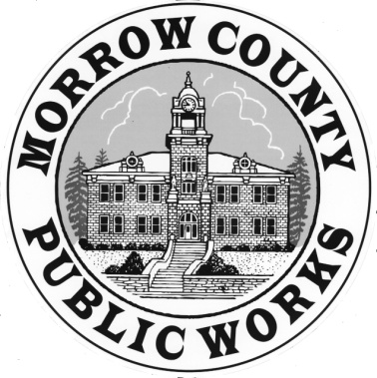 | PUBLIC WORKS DEPARTMENT  Airport General Maintenance Road Department Parks Waste Management
365 W. Highway 74 Burke O’Brien Matt Scrivner
P.O. Box 428 Director Asst. Road Master
Lexington, OR. 97839
Phone: (541) 989-9500 Sandi Pointer Kirsti Cason
Fax: (541) 989-8352 Management Asst. Administrative Asst.

AGENDA MORROW COUNTY

ROAD COMMITTEE MEETING
May 01, 2017

1:00 p.m. Bartholomew Building Upper Conference Rm., 110 N. Court St., Heppner, Oregon

- Introductions/Informal Discussion

- Review of the minutes from the 03.06.2017

- Planning Dept. Transportation System Plan

- Review of the Budget Hearings and road budget

- Set meeting date if further decisions

The meeting location is accessible to persons with disabilities. A request for an interpreter for the hearing impaired or for other accommodations for persons with disabilities should be made at least 48 hours before the meeting to Sandra Putman (541) 989-9500.

Pursuant to ORS 192.640, this agenda includes a list of the principal subjects anticipated to be considered at the meeting; however, the Committee may consider additional subjects as well.

