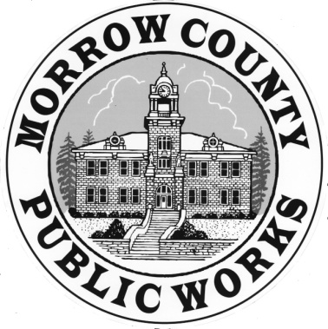 | PUBLIC WORKS DEPARTMENT  Airport General Maintenance Road Department Parks Waste Management
365 W. Highway 74 Burke O’Brien Matt Scrivner
P.O. Box 428 Director Asst. Road Master
Lexington, OR. 97839
Phone: (541) 989-9500 Sandi Putman Kirsti Cason
Fax: (541) 989-8352 Management Asst. Administrative Asst.

AGENDA MORROW COUNTY

ROAD COMMITTEE MEETING
February 9, 2017

9:00 a.m. Bartholomew Building Upper Conference Rm., 110 N. Court St., Heppner, Oregon

- Introductions/Informal Discussion

- Review of the February 4, 2016 minutes, January 12, 2017.

- Public Input and Discussion of current road committee members.

- Review of the five year projects with discussion and recommendation.

- Set meeting date if further decisions and additional road tour meeting.

The meeting location is accessible to persons with disabilities. A request for an interpreter for the hearing impaired or for other accommodations for persons with disabilities should be made at least 48 hours before the meeting to Sandra Putman (541) 989-9500.

Pursuant to ORS 192.640, this agenda includes a list of the principal subjects anticipated to be considered at the meeting; however, the committee may consider additional subjects as well. This meeting is open to the public and interested citizens are invited to attend.

