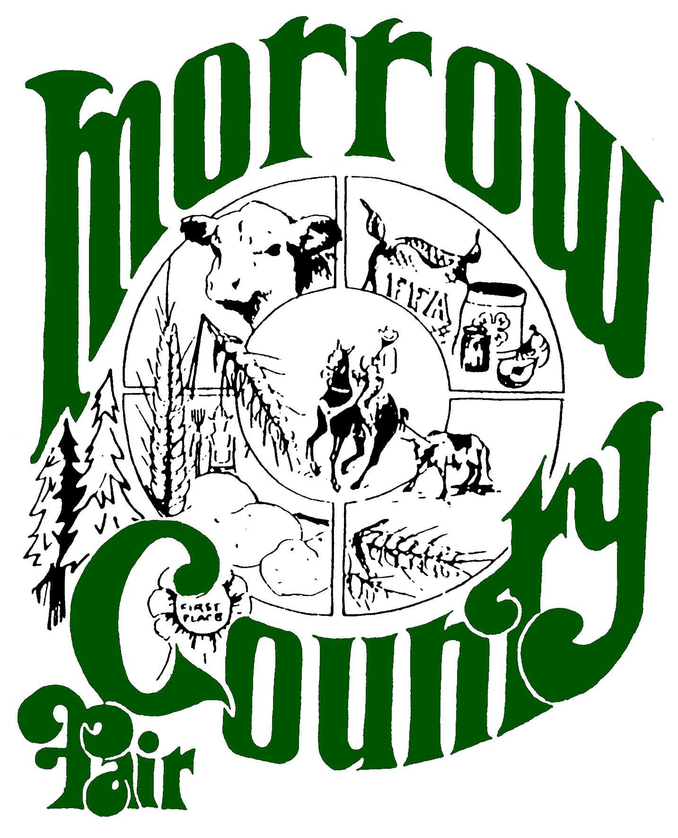

# FOR IMMEDIATE RELEASE

**Contact: Sue Gibbs**

**541-379-3998**

**541-676-9474**

**December 5th, 2024**

**MORROW COUNTY FAIR**

**2025 FAIR and RODEO QUEEN APPLICATIONS NOW AVAILABLE!**

After a ten-year lapse, the Morrow County Fair queen application is now open to Morrow County Residents and neighboring counties.

The Morrow County queen program is open to students enrolled in 9th, 10th, 11th and 12th grade students between the ages of 14 and 19.

Applications are available at the Fair Office, on the Morrow County Web site, Sage Center, Green Feed and Morrow County High Schools. These can be mailed to Morrow County fair at P.O. Box 464, Heppner, OR 97836 or emailed to: mcfair@morrowcountyor.gov

This is a great opportunity for a young person to represent Morrow County not only during the week of fair in August, but at parades, rodeos and other functions throughout Eastern Oregon in 2025.

Fair Court applications are due to the Fair Office no later than **12:00 PM on Monday, Dec. 31st, 2024**. Please make sure applications are complete with required documentation and delivered before the end of the year. Fair staff will contact all accepted applicants to schedule interviews in January.

[For additional information please](mailto:angie.mcnalley@umatillacounty.net) contact the Fair Office at (541) 379-3998 or email: [mcfair@morrowcountyor.govs](mailto:mcfair@morrowcountyor.govs)